**Practical Exercise: Periodic Execution of Integration Processes**

Training Objective

Configure scheduled tasks to run integration processes using WSO2 Integration Studio.

High-level Steps

* Configure the integration artifacts.
* Deploy and test your new configuration.

Detailed Instructions

Periodic Execution of Integration Process

What you'll build

The sections below demonstrate an example of scheduling a task (using the default implementation) to inject an XML message and to print it in the logs of the server.

Let's get started!

Step 1: Set up the workspace

Download the relevant [WSO2 Integration Studio](https://wso2.com/api-management/tooling/) based on your operating system.

Step 2: Develop the integration artifacts

Follow the instructions given in this section to create and configure the required artifacts.

**Create an Integration Project**

An Integration project is a maven multi module project, which will contain all the required modules for the integration solution.

1. Open **WSO2 Integration Studio**.
2. Click **New Integration Project** in the **Getting Started** tab as shown below.

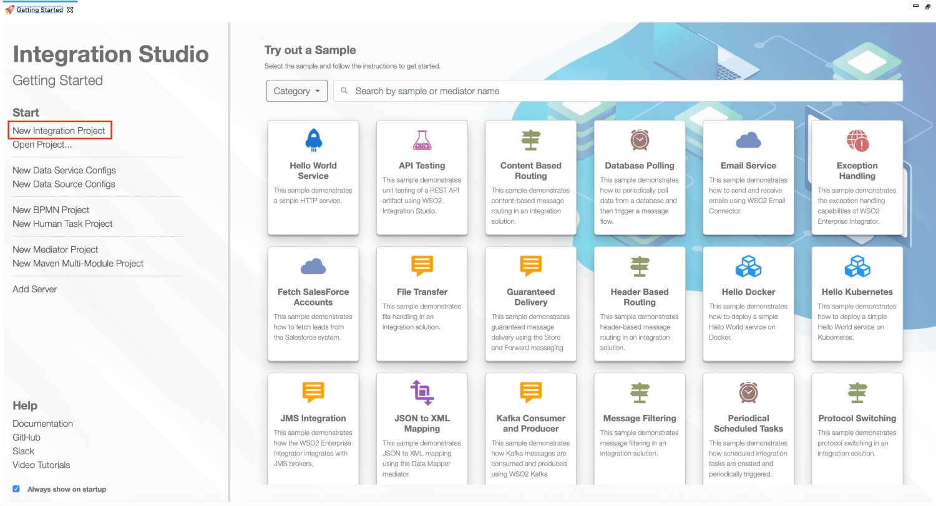

This will open the **New Integration Project** dialog box.

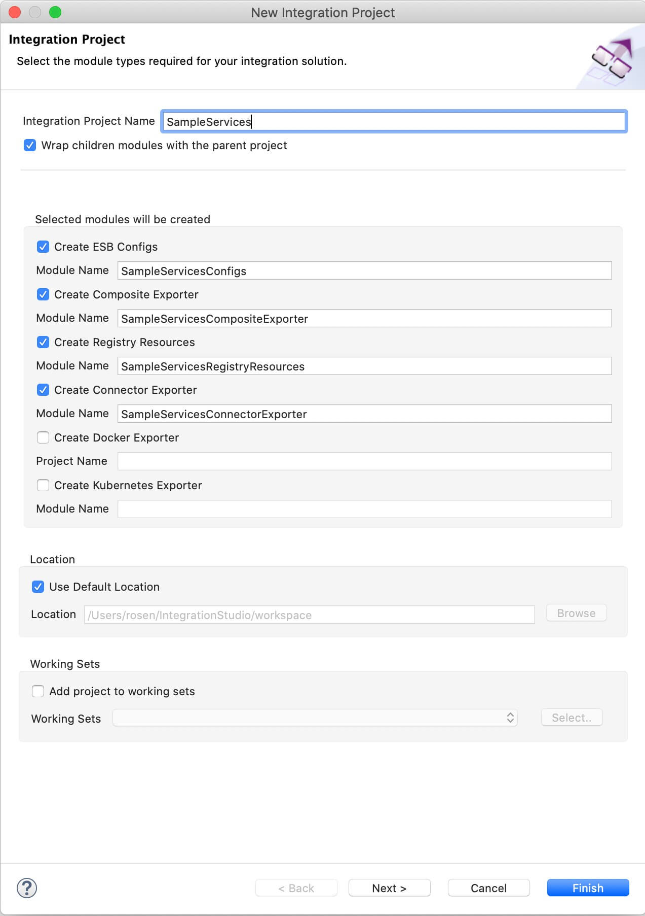

1. Enter SampleServices as the project name and select the following check boxes to create the required modules.
   * **Create ESB Configs**
   * **Create Composite Exporter**
2. Click **Finish**.

You will now see the projects listed in the **Project Explorer**.

**Creating the Sequence**

1. In the **Project Explorer**, right click **ScheduleDefaultTaskConfigs** project, and click **New** → **Sequence**.  
   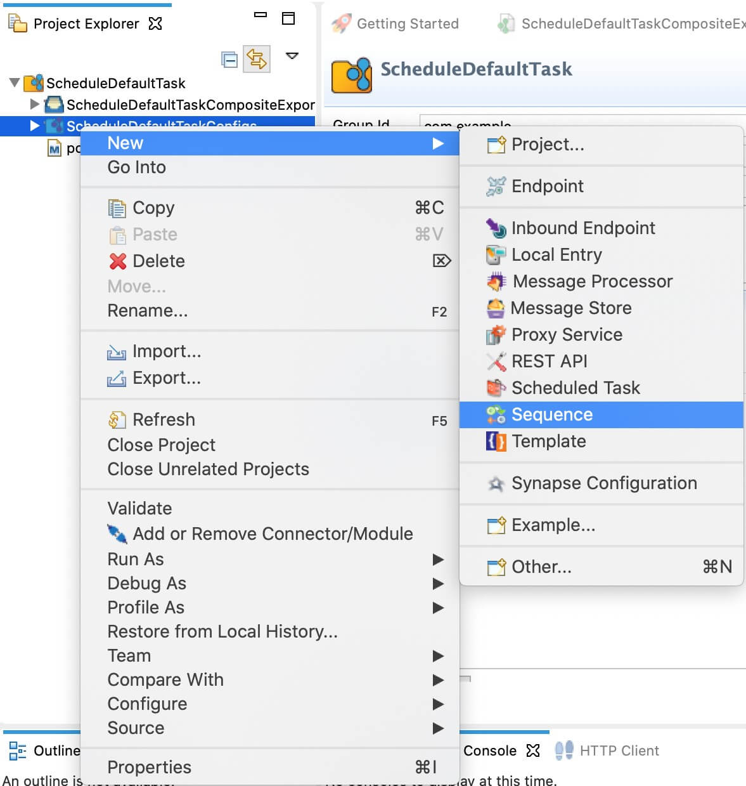
2. Click **Create New Sequence** and click **Next**.
3. Enter **InjectXMLSequence** as the sequence name and click **Finish**.  
   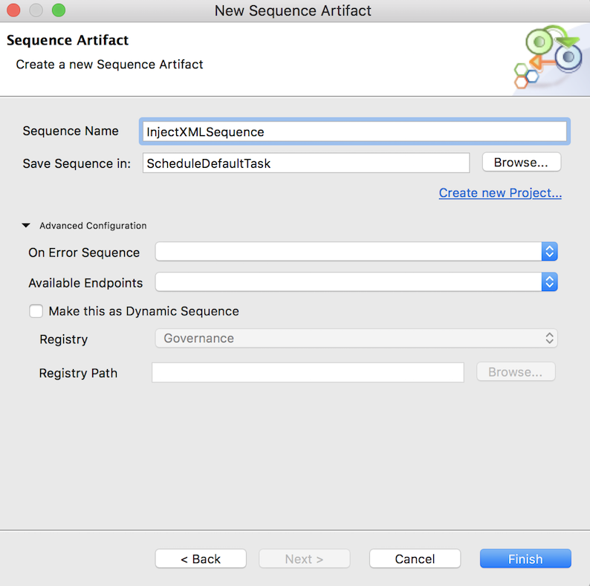
4. Drag and drop a **Log** mediator and a **Drop** mediator from the **Mediators** Palette.  
   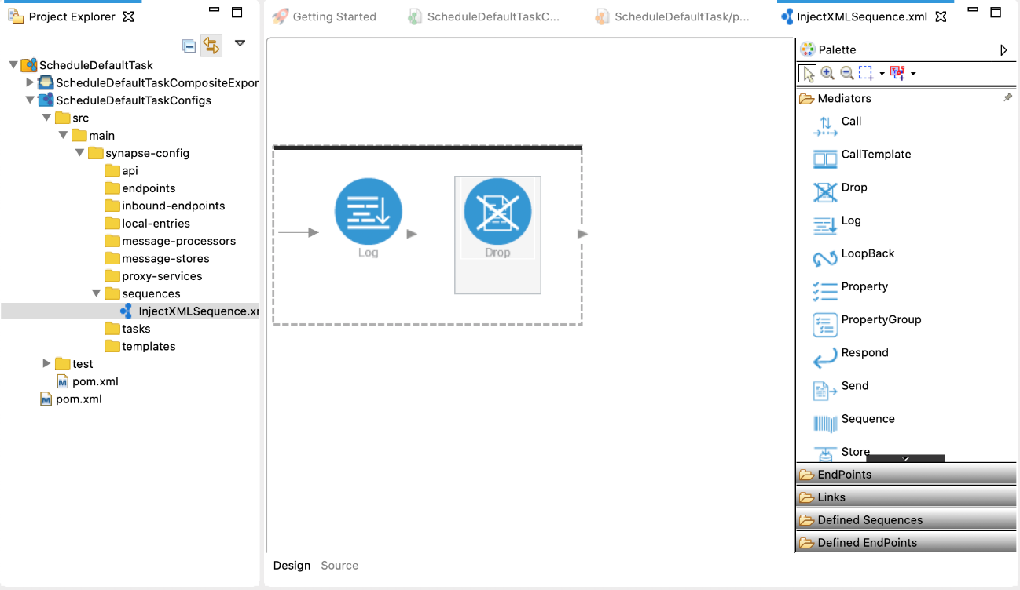
5. Click the **Log** mediator and enter the following details in the **Properties** section.
   * **Log Category**: INFO
   * **Log Level**: CUSTOM
   * Add a new property with the following details:

|  |  |
| --- | --- |
| Property | Description |
| Property Name | City |
| Value Type | EXPRESSION |
| Expression | //city |

Shown below is the complete source configuration of the Sequence (i.e., the InjectXMLSequence.xml file).

<?xml version="1.0" encoding="UTF-8"?>

<**sequence** name="InjectXMLSequence" trace="disable" xmlns="http://ws.apache.org/ns/synapse">

<**log** level="custom">

<**property** expression="//city" name="City"/>

</**log**>

<**drop**/>

</**sequence**>

**Creating the Scheduled Task**

1. In the **Project Explorer**, right click **ScheduleDefaultTask**, and click **New → Scheduled Task**. 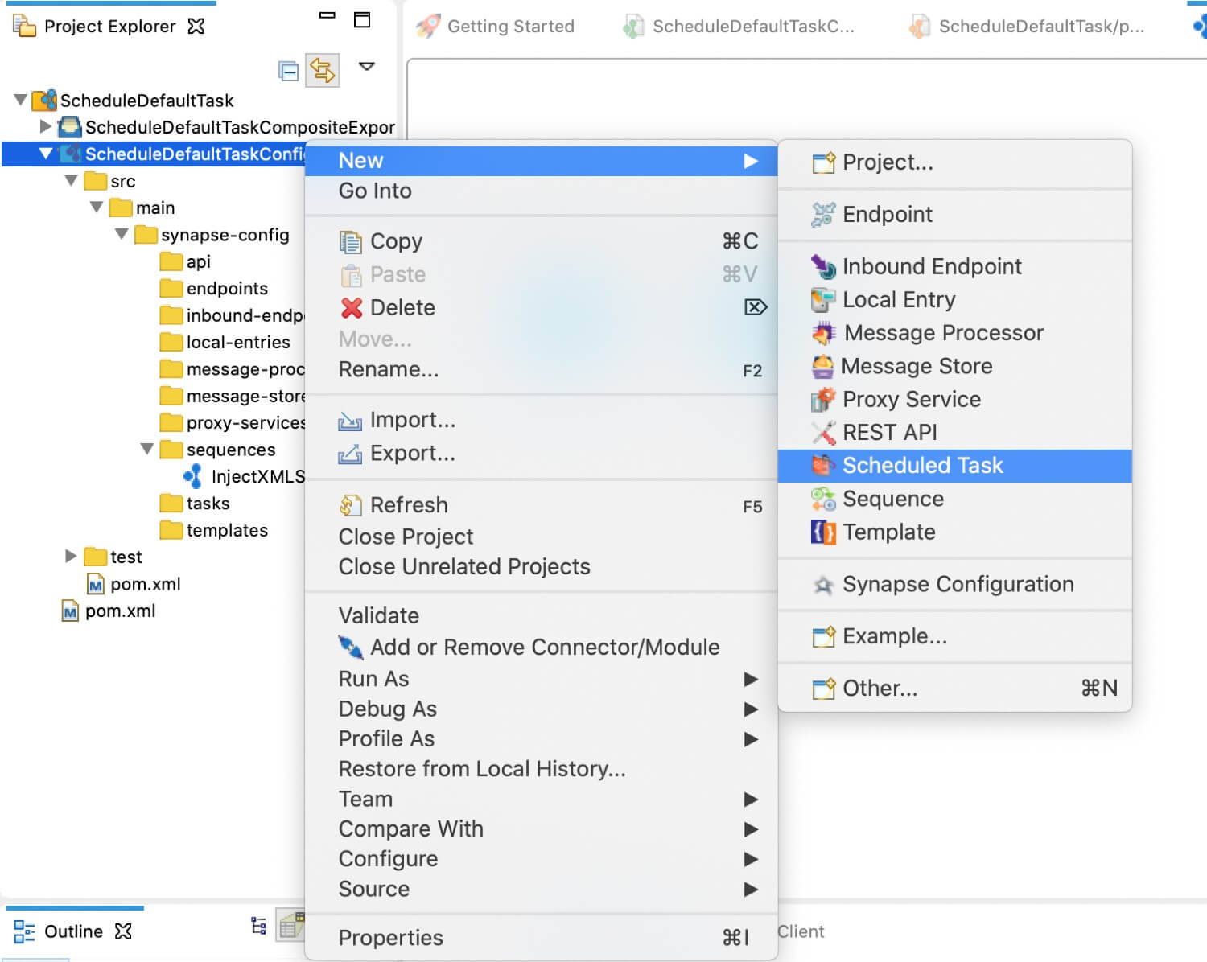
2. Select **Create a New Scheduled Task Artifact** and click **Next**.

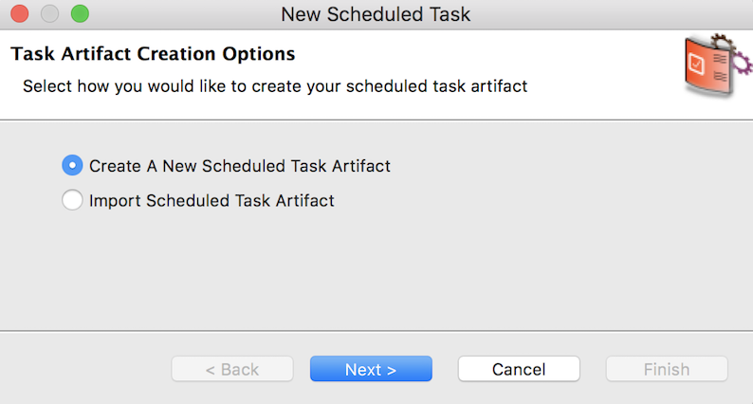

1. Enter the following details and click **Next**:
   * **Task Name:** InjectXMLTask
   * **Count:** -1
   * **Interval (in seconds):** 5

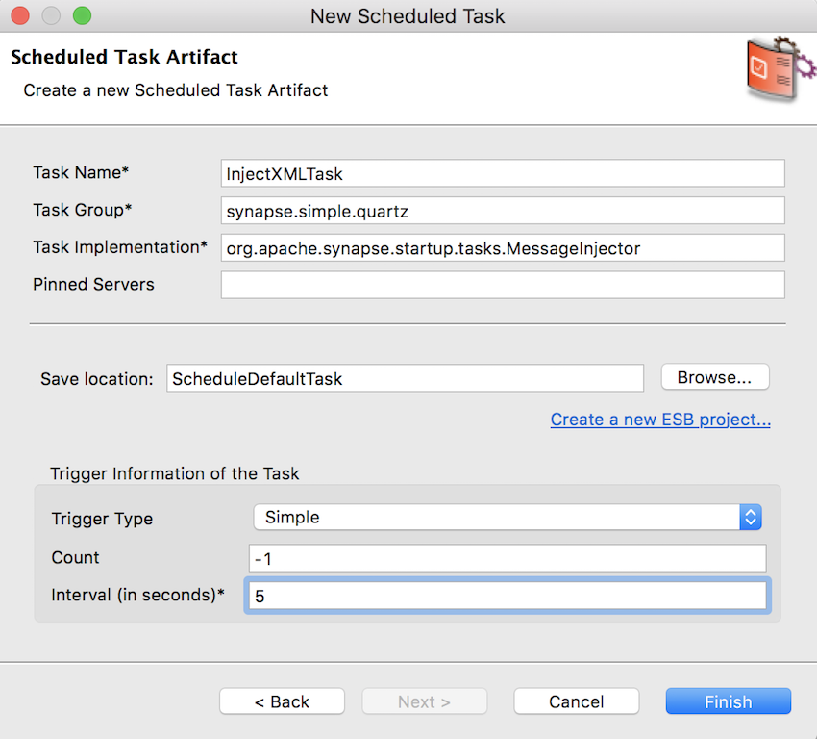

1. In the **Form View** of the InjectXMLTask task, click **Task Implementation Properties**.

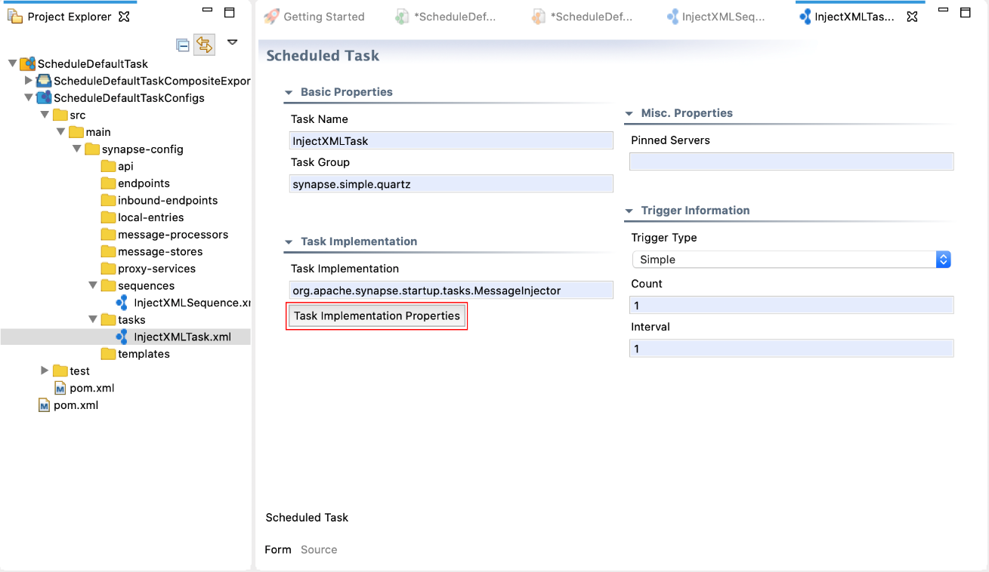

* + Enter the following parameters:
    - **injectTo:** sequence
    - **sequenceName:** InjectXMLSequence
  + Select **XML** as the **Parameter Type** of the **message** parameter, and enter the following as the XML message in the **Value/Expression** field and click **OK**.

<**request** xmlns=""> <**location**> <**city**>London</**city**> <**country**>UK</**country**> </**location**> </**request**>

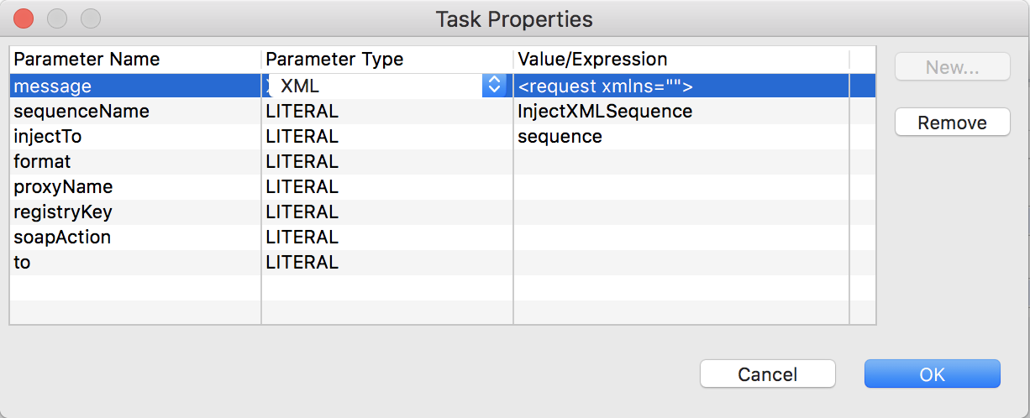

Shown below is the complete source configuration of the scheduled task.

<?xml version="1.0" encoding="UTF-8"?>

<**task** class="org.apache.synapse.startup.tasks.MessageInjector" group="synapse.simple.quartz" name="InjectXMLTask" xmlns="http://ws.apache.org/ns/synapse">

<**trigger** interval="5"/>

<**property** name="injectTo" value="sequence" xmlns:task="http://www.wso2.org/products/wso2commons/tasks"/>

<**property** name="sequenceName" value="InjectXMLSequence" xmlns:task="http://www.wso2.org/products/wso2commons/tasks"/>

<**property** name="message" xmlns:task="http://www.wso2.org/products/wso2commons/tasks">

<**request** xmlns="">

<**location**>

<**city**>London</**city**>

<**country**>UK</**country**>

</**location**>

</**request**>

</**property**>

</**task**>

Step 3: Package the artifacts

Package the artifacts in your composite application module to be able to deploy the artifacts in the server.

1. Open the pom.xml file in the composite exporter module.
2. Ensure that the relevant artifacts are selected in the POM file.
3. Save the changes.

Step 4: Build and run the artifacts

To test the artifacts, deploy the [packaged artifacts](https://apim.docs.wso2.com/en/latest/tutorials/integration-tutorials/using-scheduled-tasks/#step-3-package-the-artifacts) in the embedded Micro Integrator:

1. Right-click the composite exporter module and click **Export Project Artifacts and Run**.
2. In the dialog box that opens, confirm that the required artifacts from the composite exporter module are selected.
3. Click **Finish**.

The artifacts will be deployed in the embedded Micro Integrator and the server will start.

* See the startup log in the **Console** tab.
* See the URLs of the deployed services and APIs in the **Runtime Services** tab.

Step 5: Test the use case

You will view the XML message you injected getting printed in the logs of the Micro Integrator every 5 seconds.

[2019-10-10 19:33:00,602] INFO {org.wso2.micro.integrator.ntask.core.impl.AbstractQuartzTaskManager} - Task scheduled: [-1234][ESB_TASK][InjectXMLTask]

[2019-10-10 19:33:00,671] INFO {org.apache.synapse.mediators.builtin.LogMediator} - City = London

[2019-10-10 19:33:05,602] INFO {org.apache.synapse.mediators.builtin.LogMediator} - City = London

[2019-10-10 19:33:10,603] INFO {org.apache.synapse.mediators.builtin.LogMediator} - City = London

[2019-10-10 19:33:15,605] INFO {org.apache.synapse.mediators.builtin.LogMediator} - City = London

[2019-10-10 19:33:20,600] INFO {org.apache.synapse.mediators.builtin.LogMediator} - City = London

[2019-10-10 19:33:25,600] INFO {org.apache.synapse.mediators.builtin.LogMediator} - City = London

[2019-10-10 19:33:30,601] INFO {org.apache.synapse.mediators.builtin.LogMediator} - City = London

[2019-10-10 19:33:35,605] INFO {org.apache.synapse.mediators.builtin.LogMediator} - City = London

[2019-10-10 19:33:40,603] INFO {org.apache.synapse.mediators.builtin.LogMediator} - City = London

[2019-10-10 19:33:45,600] INFO {org.apache.synapse.mediators.builtin.LogMediator} - City = London

[2019-10-10 19:33:50,605] INFO {org.apache.synapse.mediators.builtin.LogMediator} - City = London

[2019-10-10 19:33:55,603] INFO {org.apache.synapse.mediators.builtin.LogMediator} - City = London

[2019-10-10 19:34:00,605] INFO {org.apache.synapse.mediators.builtin.LogMediator} - City = London

[2019-10-10 19:34:05,605] INFO {org.apache.synapse.mediators.builtin.LogMediator} - City = London

[2019-10-10 19:34:10,599] INFO {org.apache.synapse.mediators.builtin.LogMediator} - City = London

[2019-10-10 19:34:15,607] INFO {org.apache.synapse.mediators.builtin.LogMediator} - City = London

[2019-10-10 19:34:20,605] INFO {org.apache.synapse.mediators.builtin.LogMediator} - City = London

[2019-10-10 19:34:25,603] INFO {org.apache.synapse.mediators.builtin.LogMediator} - City = London